# Stop

Search “Stop herein”

# 10-Upper Intermediate

# Meeting type

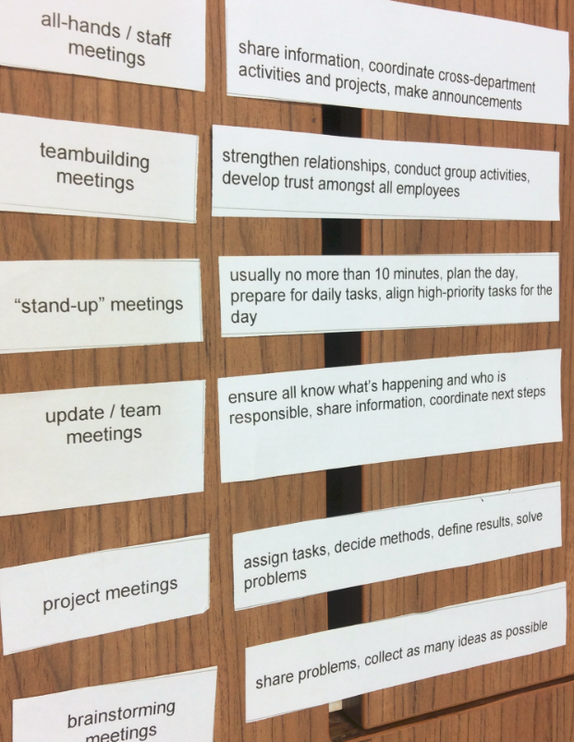

# Unit 1: Meetings

## **Dictionary**

See C:\Tracy\TW related\English\IETLS\oral topic\2 EF oral topics - Script based on Level\EF oral topics_L10-Upper Intermediate

## Part 1 Start/open a meeting

### **Start** a meeting

Host: **OK everyone, If I could have your attention please, let’s get started.**

Firstly, thank you all for coming today. **I know how busy you all are.**

**Well, do you all have the copy of the agenda? As you can see, we have *three* items to discuss today.** **The purpose of our meeting is** to talk about the relationship between us and the Sunset Computer since the merger. **We’re all here because** we do the most of business with them.

**Well, let’s start with the 1st item on the agenda. The 1st item** is the news of Sunset Computer. Are you all aware that the JPMorgan’s CEO has resigned?

Members: No, I don’t know that.

Members: **Me neither / Nor do I**

Host: OK, well, that means that our relationship with JPMorgan wasn’t working…The JPMorgan financial chief officer Maggie will be also leaving…

Member: that’s good news. I think it’s time to change

Host: **OK, let’s move on to the next item on the agenda.** I’m probably flying out to meet with JPMorgan’s executives next Mon. The CEOs might have more information about the merger late next Mon.

**The last item on the agenda** is our problems with Sunset. I’ve been hearing lots of complain from some people here, but I need more detailed information. So can you please help **glean** more information for me? [ glean information: to collect or learn sth slowly and patiently]

Member: For me, the primary problem is the communication between us and Sunset. We **lack of** that.

Host: Could you be more specific?

Member: Well, they’re very slowly answering our questions. For instance, yesterday, I reached out to their financial director, leaving him message and then I sent an email, and still no answer….

Member: The huge challenge for me is to **figure out** who is responsible for what specific thing.

Member: I have to say the IT engineers are incredible. They always provide me with information that I need very quickly, accurately, and efficiently.

🡺 Discuss proposals in the meeting 🡺

### **Dialogue1**

**Excuse me, can I have your attention please…. Great, thank you, I think it’s time to get started.**

**First, does everyone have the copy of the agenda**? **As you can see, we have** lots of things to discuss.

Good. **Well, thank you all for coming here, and I know how busy you all are**. **The purpose of the meeting today** is to give you an update about the merger that we’ve had with unset, one of our previous biggest competitors.

**We’re all here also because** I’m going to give you feedback about the proposal ideal. As you can see, **the 1st item on the agenda** is to update the financial effect of the proposed merger. OK, now, let me **turn things over** to our CFO who will give us her opinions about **the pros and cons of** the merger from finance point of view

### **Gramma**

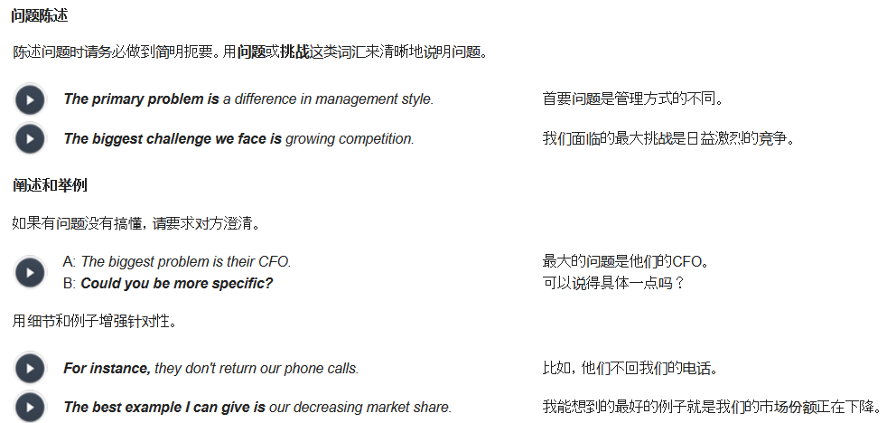

### **Dialogu2**

Host: Hello everyone, If I can have your attention please, let’s get started. Well, I call this meeting in order to update you that we’ve cancelled the **merger** negotiation with our competitor.

There are a number of issues that make the merger deal **unworkable/impractical不能实行的**.

Member: **Could you be more specific?**

Host: Certainly, **the primary issue is that two companies didn’t fit very well.** We have lots of different on the management style. **Furthermore**, the key issue is we found that the merger does not improve our business.

Member: So, we’re gonna find another company for us to merge with?

Host: No, **the big challenge** that we face is that we have to enhance our competitiveness and deal with the decreasing market share. With lots of flexibilities and creativities, that would be **a huge challenge** for all of us, and I’m confident that we’re smart enough and competent enough to **pull it off (圆满完成, 成功完成)**

### **Dialogue3**

…..

## Part 2 Discuss proposals in a meeting

Stop herein

## Part 3 Conclude a meeting

## Part 4 Summarize a meeting (MoM)